SOFTWARE ENVIRONMENT

Python:
Python is a high-level, interpreted, interactive and object-oriented scripting language. Python is designed to be highly readable. It uses English keywords frequently where as other languages use punctuation, and it has fewer syntactical constructions than other languages.
- Python is Interpreted − Python is processed at runtime by the interpreter. You do not need to compile your program before executing it. This is similar to PERL and PHP.
- Python is Interactive − You can actually sit at a Python prompt and interact with the interpreter directly to write your programs.
- Python is Object-Oriented − Python supports Object-Oriented style or technique of programming that encapsulates code within objects.
- Python is a Beginner's Language − Python is a great language for the beginner-level programmers and supports the development of a wide range of applications from simple text processing to WWW browsers to games.
History of Python
Python was developed by Guido van Rossum in the late eighties and early nineties at the National Research Institute for Mathematics and Computer Science in the Netherlands.
Python is derived from many other languages, including ABC, Modula-3, C, C++, Algol-68, SmallTalk, and Unix shell and other scripting languages.
Python is copyrighted. Like Perl, Python source code is now available under the GNU General Public License (GPL).
Python is now maintained by a core development team at the institute, although Guido van Rossum still holds a vital role in directing its progress.
Python Features
Python's features include −
- Easy-to-learn − Python has few keywords, simple structure, and a clearly defined syntax. This allows the student to pick up the language quickly.
- Easy-to-read − Python code is more clearly defined and visible to the eyes.
- Easy-to-maintain − Python's source code is fairly easy-to-maintain.
- A broad standard library − Python's bulk of the library is very portable and cross-platform compatible on UNIX, Windows, and Macintosh.
- Interactive Mode − Python has support for an interactive mode which allows interactive testing and debugging of snippets of code.
- Portable − Python can run on a wide variety of hardware platforms and has the same interface on all platforms.
- Extendable − You can add low-level modules to the Python interpreter. These modules enable programmers to add to or customize their tools to be more efficient.
- Databases − Python provides interfaces to all major commercial databases.
- GUI Programming − Python supports GUI applications that can be created and ported to many system calls, libraries and windows systems, such as Windows MFC, Macintosh, and the X Window system of Unix.
- Scalable − Python provides a better structure and support for large programs than shell scripting.
Apart from the above-mentioned features, Python has a big list of good features, few are listed below −
- It supports functional and structured programming methods as well as OOP.
- It can be used as a scripting language or can be compiled to byte-code for building large applications.
- It provides very high-level dynamic data types and supports dynamic type checking.
- It supports automatic garbage collection.
- It can be easily integrated with C, C++, COM, ActiveX, CORBA, and Java.
Python is available on a wide variety of platforms including Linux and Mac OS X. Let's understand how to set up our Python environment.
Getting Python
The most up-to-date and current source code, binaries, documentation, news, etc., is available on the official website of Python https://www.python.org.
Windows Installation
Here are the steps to install Python on Windows machine.
- Open a Web browser and go to https://www.python.org/downloads/.
- Follow the link for the Windows installer python-XYZ.msifile where XYZ is the version you need to install.
- To use this installer python-XYZ.msi, the Windows system must support Microsoft Installer 2.0. Save the installer file to your local machine and then run it to find out if your machine supports MSI.
- Run the downloaded file. This brings up the Python install wizard, which is really easy to use. Just accept the default settings, wait until the install is finished, and you are done.
The Python language has many similarities to Perl, C, and Java. However, there are some definite differences between the languages.

First Python Program
Let us execute programs in different modes of programming.

Interactive Mode Programming
Invoking the interpreter without passing a script file as a parameter brings up the following prompt −
$ python
Python2.4.3(#1,Nov112010,13:34:43)
[GCC 4.1.220080704(RedHat4.1.2-48)] on linux2
Type"help","copyright","credits"or"license"for more information.
>>>
Type the following text at the Python prompt and press the Enter −
>>>print"Hello, Python!"
If you are running new version of Python, then you would need to use print statement with parenthesis as in print ("Hello, Python!");. However in Python version 2.4.3, this produces the following result −
Hello, Python!

Script Mode Programming
Invoking the interpreter with a script parameter begins execution of the script and continues until the script is finished. When the script is finished, the interpreter is no longer active.
Let us write a simple Python program in a script. Python files have extension .py. Type the following source code in a test.py file −
print"Hello, Python!"
We assume that you have Python interpreter set in PATH variable. Now, try to run this program as follows −
$ python test.py
This produces the following result −
Hello, Python!

Flask Framework:
Flask is a web application framework written in Python. Armin Ronacher, who leads an international group of Python enthusiasts named Pocco, develops it. Flask is based on Werkzeug WSGI toolkit and Jinja2 template engine. Both are Pocco projects.
Http protocol is the foundation of data communication in world wide web. Different methods of data retrieval from specified URL are defined in this protocol.
The following table summarizes different http methods −
Sr.No | Methods & Description
1 | GET  Sends data in unencrypted form to the server. Most common method.
2 | HEAD  Same as GET, but without response body
3 | POST  Used to send HTML form data to server. Data received by POST method is not cached by server.
4 | PUT  Replaces all current representations of the target resource with the uploaded content.
5 | DELETE  Removes all current representations of the target resource given by a URL
By default, the Flask route responds to the GET requests. However, this preference can be altered by providing methods argument to route() decorator.
In order to demonstrate the use of POST method in URL routing, first let us create an HTML form and use the POST method to send form data to a URL.
Save the following script as login.html
<html>
<body>
<formaction="http://localhost:5000/login"method="post">
<p>Enter Name:</p>
<p><inputtype="text"name="nm"/></p>
<p><inputtype="submit"value="submit"/></p>
</form>
</body>
</html>
Now enter the following script in Python shell.
from flask importFlask, redirect,url_for, request
app=Flask(__name__)
@app.route('/success/<name>')
def success(name):
return'welcome %s'% name
@app.route('/login',methods=['POST','GET'])
def login():
ifrequest.method=='POST':
user=request.form['nm']
return redirect(url_for('success',name= user))
else:
user=request.args.get('nm')
return redirect(url_for('success',name= user))
if __name__ =='__main__':
app.run(debug =True)
After the development server starts running, open login.html in the browser, enter name in the text field and click Submit.
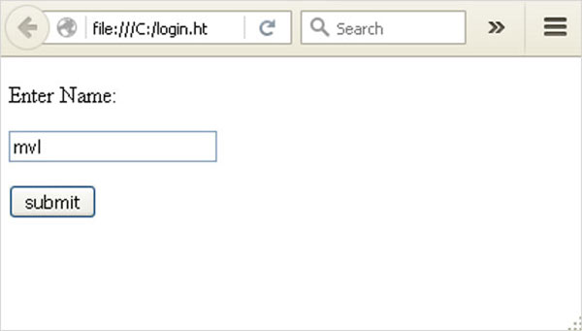
Form data is POSTed to the URL in action clause of form tag.
http://localhost/login is mapped to the login() function. Since the server has received data by POST method, value of ‘nm’ parameter obtained from the form data is obtained by −
user = request.form['nm']
It is passed to ‘/success’ URL as variable part. The browser displays a welcome message in the window.
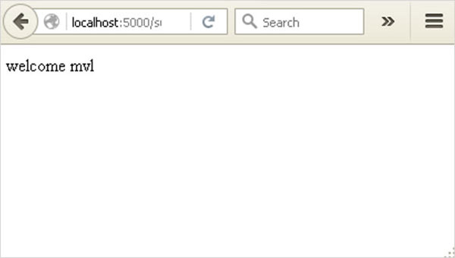
Change the method parameter to ‘GET’ in login.html and open it again in the browser. The data received on server is by the GET method. The value of ‘nm’ parameter is now obtained by −
User = request.args.get(‘nm’)
Here, args is dictionary object containing a list of pairs of form parameter and its corresponding value. The value corresponding to ‘nm’ parameter is passed on to ‘/success’ URL as before.

What is Python?
Python is a popular programming language. It was created in 1991 by Guido van Rossum.
It is used for:
- web development (server-side),
- software development,
- mathematics,
- system scripting.
What can Python do?
- Python can be used on a server to create web applications.
- Python can be used alongside software to create workflows.
- Python can connect to database systems. It can also read and modify files.
- Python can be used to handle big data and perform complex mathematics.
- Python can be used for rapid prototyping, or for production-ready software development.
Why Python?
- Python works on different platforms (Windows, Mac, Linux, Raspberry Pi, etc).
- Python has a simple syntax similar to the English language.
- Python has syntax that allows developers to write programs with fewer lines than some other programming languages.
- Python runs on an interpreter system, meaning that code can be executed as soon as it is written. This means that prototyping can be very quick.
- Python can be treated in a procedural way, an object-orientated way or a functional way.
Good to know
- The most recent major version of Python is Python 3, which we shall be using in this tutorial. However, Python 2, although not being updated with anything other than security updates, is still quite popular.
- In this tutorial Python will be written in a text editor. It is possible to write Python in an Integrated Development Environment, such as Thonny, Pycharm, Netbeans or Eclipse which are particularly useful when managing larger collections of Python files.
Python Syntax compared to other programming languages
- Python was designed to for readability, and has some similarities to the English language with influence from mathematics.
- Python uses new lines to complete a command, as opposed to other programming languages which often use semicolons or parentheses.
- Python relies on indentation, using whitespace, to define scope; such as the scope of loops, functions and classes. Other programming languages often use curly-brackets for this purpose.

Python Install
Many PCs and Macs will have python already installed.
To check if you have python installed on a Windows PC, search in the start bar for Python or run the following on the Command Line (cmd.exe):
C:\Users\Your Name>python --version
To check if you have python installed on a Linux or Mac, then on linux open the command line or on Mac open the Terminal and type:
python --version
If you find that you do not have python installed on your computer, then you can download it for free from the following website: https://www.python.org/

Python Quickstart
Python is an interpreted programming language, this means that as a developer you write Python (.py) files in a text editor and then put those files into the python interpreter to be executed.
The way to run a python file is like this on the command line:
C:\Users\Your Name>python helloworld.py
Where "helloworld.py" is the name of your python file.
Let's write our first Python file, called helloworld.py, which can be done in any text editor.
helloworld.py
print("Hello, World!")
Simple as that. Save your file. Open your command line, navigate to the directory where you saved your file, and run:
C:\Users\Your Name>python helloworld.py
The output should read:
Hello, World!
Congratulations, you have written and executed your first Python program.

The Python Command Line
To test a short amount of code in python sometimes it is quickest and easiest not to write the code in a file. This is made possible because Python can be run as a command line itself.
Type the following on the Windows, Mac or Linux command line:
C:\Users\Your Name>python
From there you can write any python, including our hello world example from earlier in the tutorial:
C:\Users\Your Name>python
Python 3.6.4 (v3.6.4:d48eceb, Dec 19 2017, 06:04:45) [MSC v.1900 32 bit (Intel)] on win32
Type "help", "copyright", "credits" or "license" for more information.
>>> print("Hello, World!")
Which will write "Hello, World!" in the command line:
C:\Users\Your Name>python
Python 3.6.4 (v3.6.4:d48eceb, Dec 19 2017, 06:04:45) [MSC v.1900 32 bit (Intel)] on win32
Type "help", "copyright", "credits" or "license" for more information.
>>> print("Hello, World!")
Hello, World!
Whenever you are done in the python command line, you can simply type the following to quit the python command line interface:
exit()
Execute Python Syntax
As we learned in the previous page, Python syntax can be executed by writing directly in the Command Line:
>>> print("Hello, World!")
Hello, World!
Or by creating a python file on the server, using the .py file extension, and running it in the Command Line:
C:\Users\Your Name>python myfile.py

Python Indentations
Where in other programming languages the indentation in code is for readability only, in Python the indentation is very important.
Python uses indentation to indicate a block of code.
Example
if 5 > 2:
print("Five is greater than two!")
Python will give you an error if you skip the indentation:
Example
if 5 > 2:
print("Five is greater than two!")

Comments
Python has commenting capability for the purpose of in-code documentation.
Comments start with a #, and Python will render the rest of the line as a comment:
Example
Comments in Python:
#This is a comment.
print("Hello, World!")
Docstrings
Python also has extended documentation capability, called docstrings.
Docstrings can be one line, or multiline.
Python uses triple quotes at the beginning and end of the docstring:
Example
Docstrings are also comments:
"""This is a
multiline docstring."""
print("Hello, World!")

